Maryland Green Center Application 2014
Center Name: Elms Environmental Education Center
Center MAILING Address: 23160 Moakley Street, Leonardtown MD 20650
Center Physical Address: 49300 St. James Church Road, Dameron MD 20628 (NO mail delivery)
County, School System if Applicable: St. Mary’s County Schools # Staff 8 #Volunteers 4
Name of Contact Person: Hester Burch | Email: hester.burch@gmail.com
Center Phone: 301-862-3964; 301-475-5511 x32101 | Home Phone of Point of Contact: 301-994-0757
Name of Director: Margarita Rochow | Fax: 301-475-4229
Director’s Email: mrrochow@smcps.org | Center Website Address: elms.smcps.org
PART I: Cover Sheet

I have reviewed the information in this application and certify that to the best of my knowledge it is accurate. X Yes ____No

MAEOE has permission to use our photographs for promotional purposes. ____Yes X No

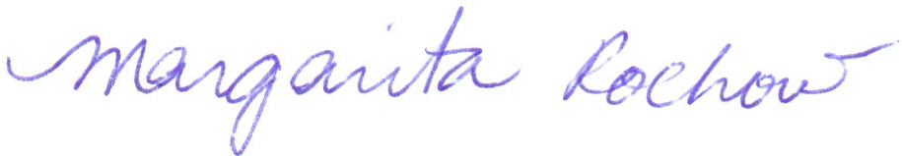 24 February 2014
Director’s Signature Date

A Committee must be involved in the preparation of the application. The committee should include, but is not limited to a student, teacher, administrator, parent, community partner, and facility person. If needed, you may add additional lines to the table.
POSITION | NAME | EMAIL
Student (optional) | Whitney Rupard | wdawkins@smcm.edu
Non-formal Educator | Denise Shrum | deeshrum51@gmail.com
Administrator | Margarita Rochow | mrrochow@smcps.org
Community Partner | Bob Boxwell | bobboxwell@hotmail.com
Facility Personnel | Kurt Reitz | kreitz@smcps.org
Formal Educator | Madison Morgan | mgmorgan@smcps.org

